myTech FERPA Access
Login with username (personal email or ID Number) and password (they set their password).
NOTE: We can do password resets for them in J1.

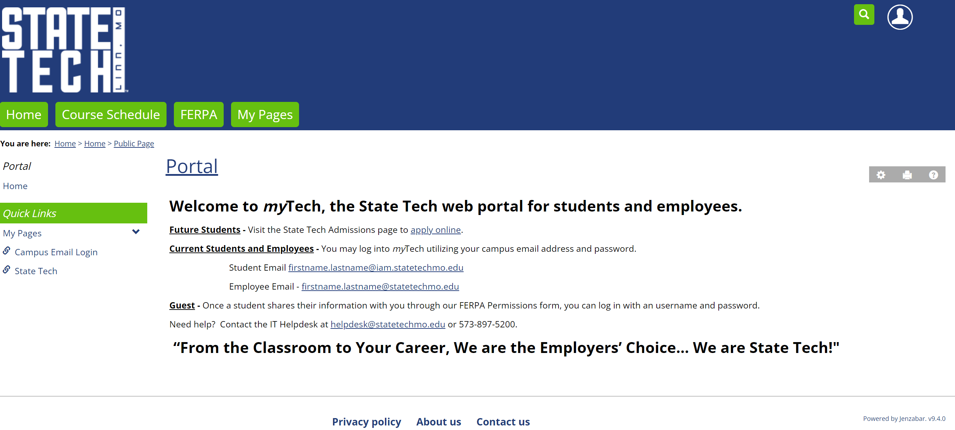

Select the – FERPA tab
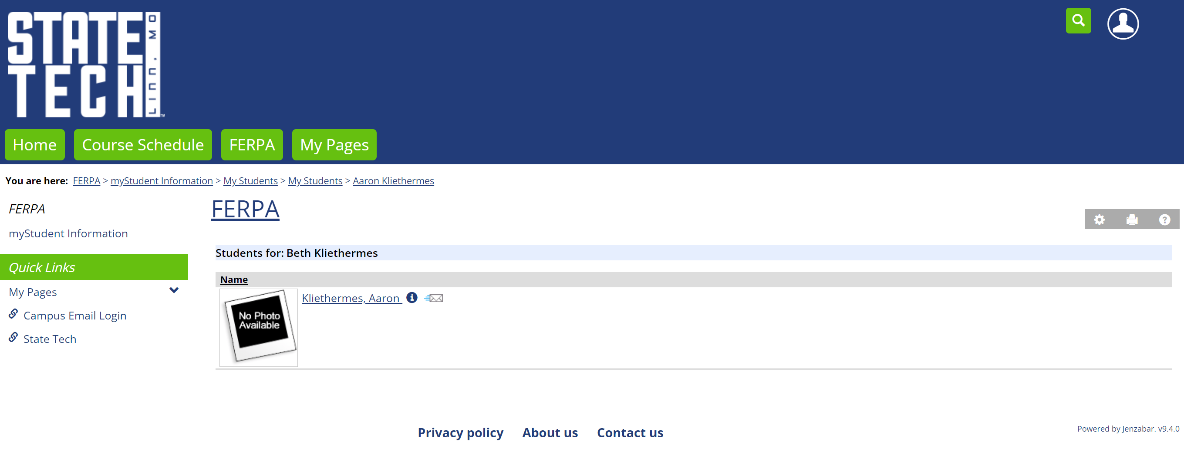
The student(s) will be shown.

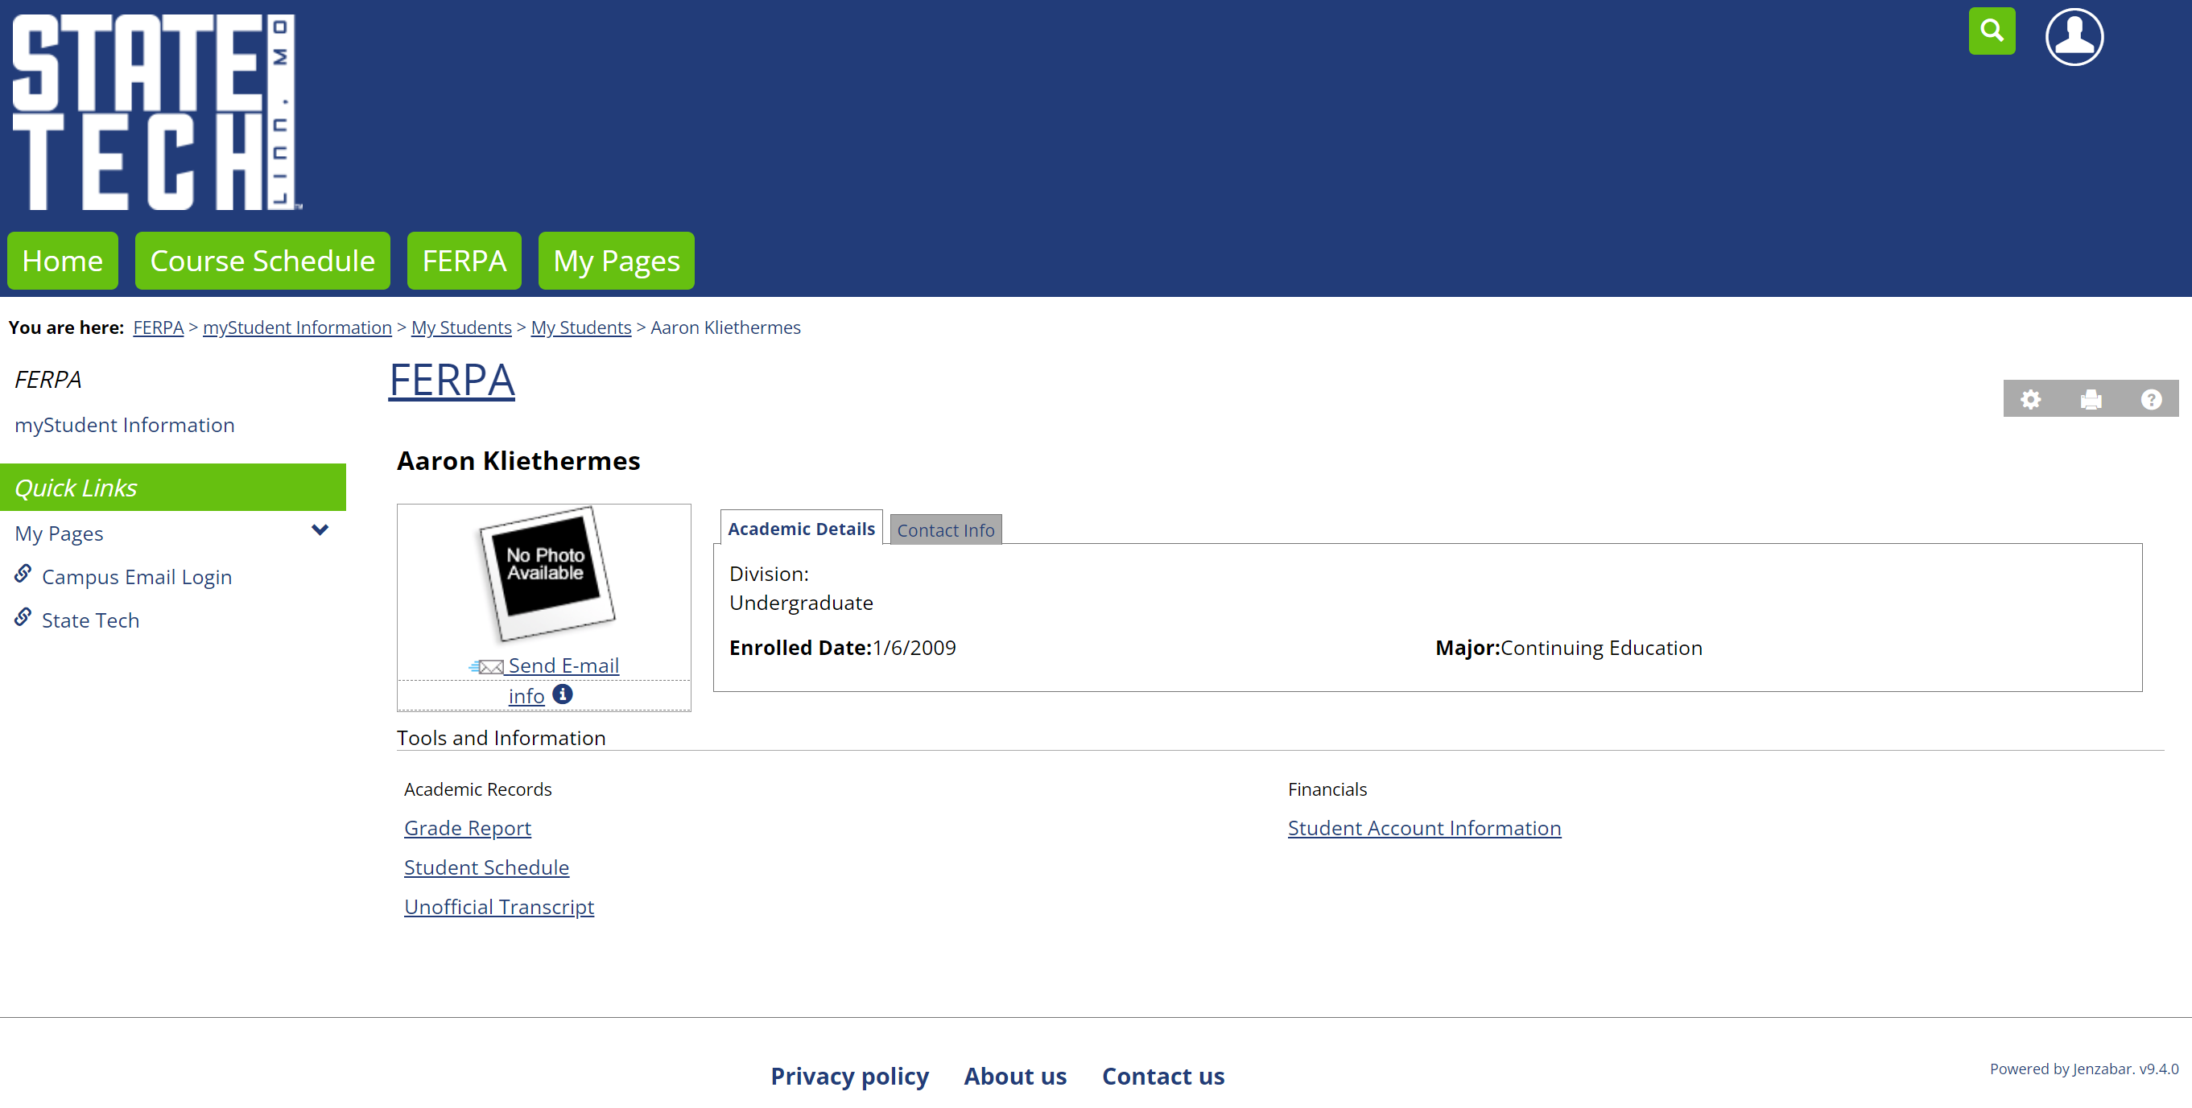
Information will be shown in “Academic Records” and or “Financials” depending upon what access was granted from the student.

