Instructions for Printing Schedules from a Desktop Computer

- Log into myTech.

- Select the “Student” tab at the top of the page.

- Proceed to the “myCourse Information” page on the left side of the screen.
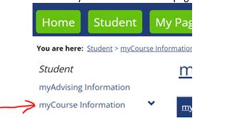

- Make sure the Term Drop down box is updated for the semester schedule you want to view. The PDF version of myCourseSchedule can be printed.

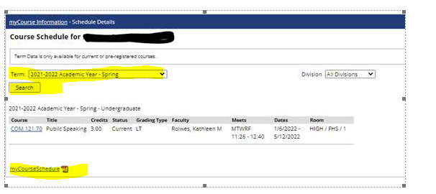

Instructions for Printing Schedules from a Mobile Phone

- Log into myTech.

- Select the “Hamburger” symbol, then the Student tab at the top of the page.

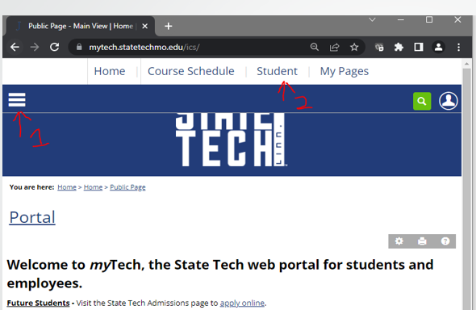

- Click the white arrow button at the bottom left of the page.
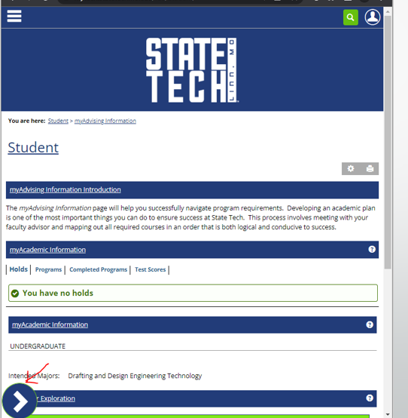

- Proceed to the “myCourse Information” page on the left side of the screen.
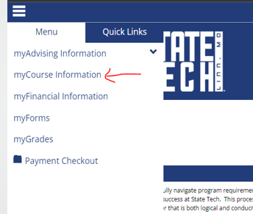

- Make sure the Term Drop down box is updated for the semester schedule you want to view. The PDF version of myCourseSchedule can be printed.

