MOBILE DEVICE
Log into mytech.statetechmo.edu/ics
Username = firstname.lastname@iam.statetechmo.edu
Password = Email Password
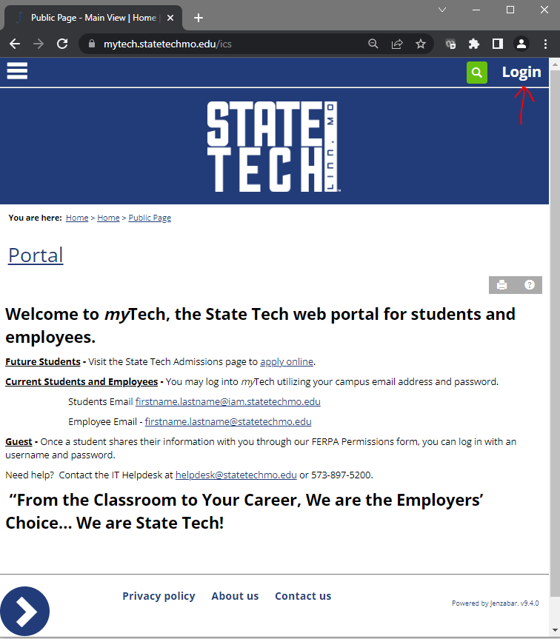

Select the hamburger icon in the upper left corner and then select “Student”
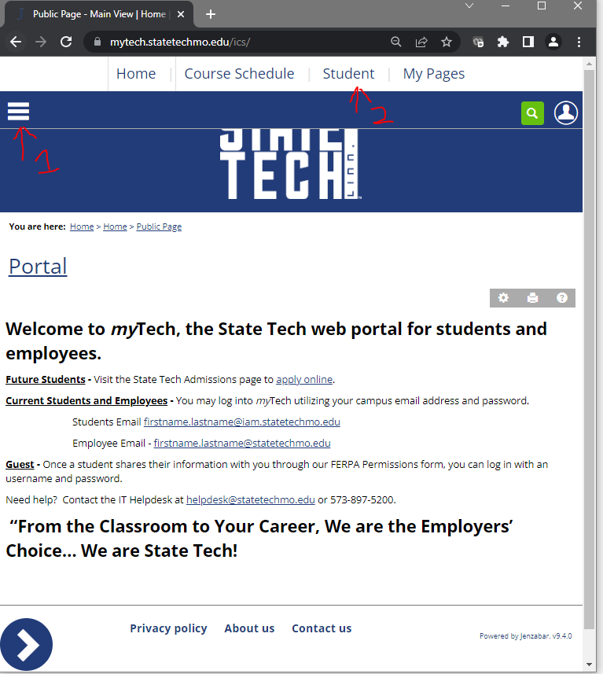

DESKTOP
Log into mytech.statetechmo.edu/ics
Username = firstname.lastname@iam.statetechmo.edu
Password = Email Password
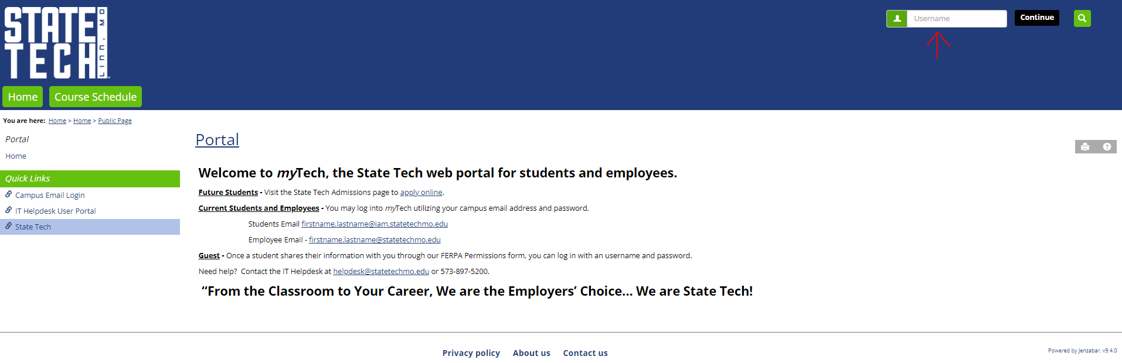

Select the “Student” tab
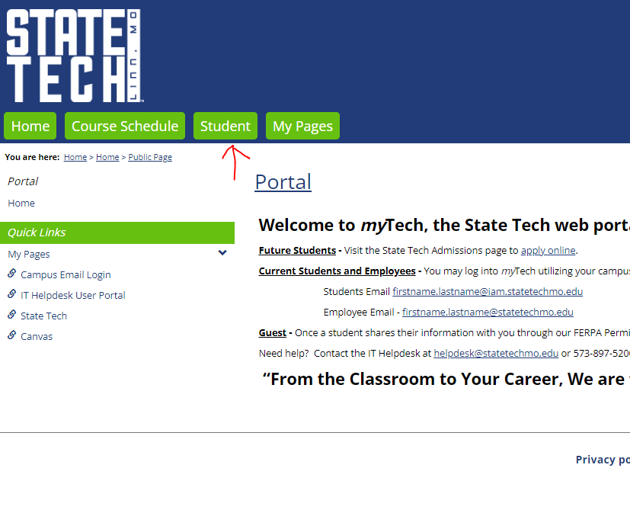

Select the arrow icon in the bottom left corner of the screen.
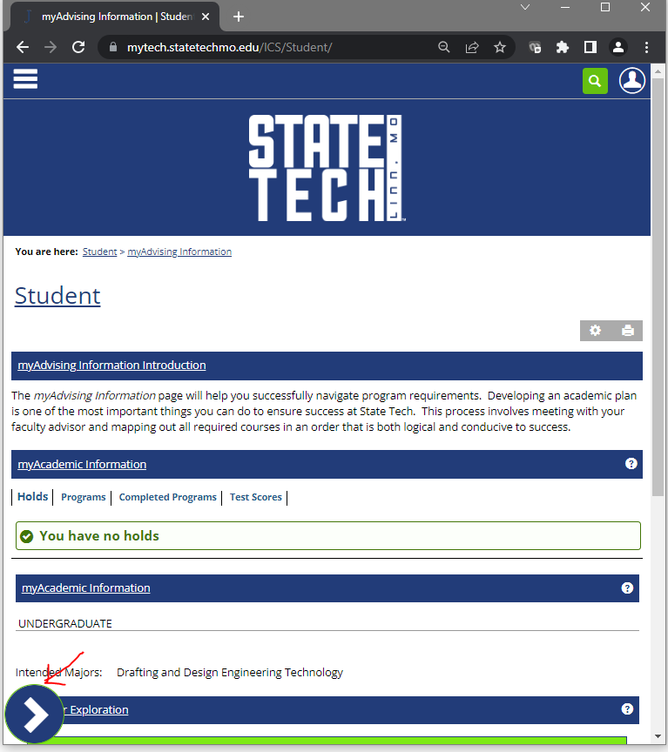

Select “myCourse Information”
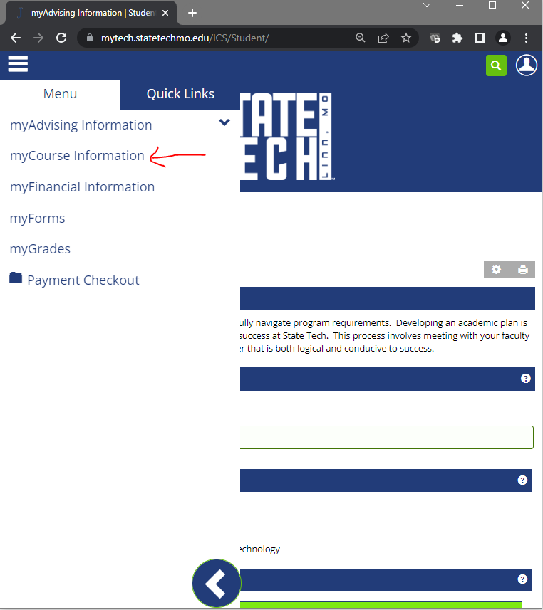

Select “myCourse Information”
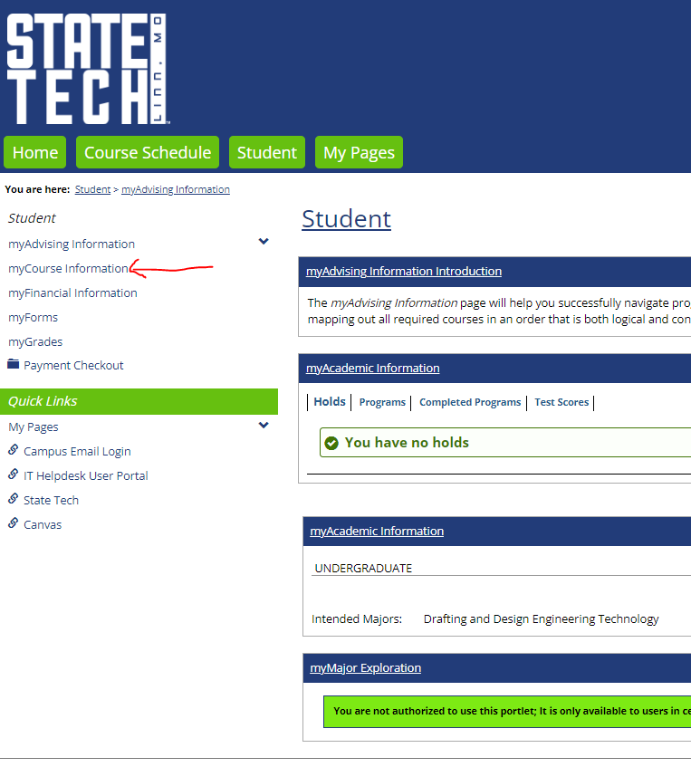

Scroll to the bottom to “myRegistration Forms” and complete the Student Schedule Confirmation Form.
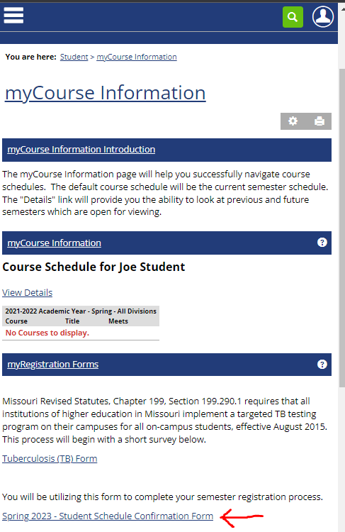
Once completed, verify both forms show “Submitted”
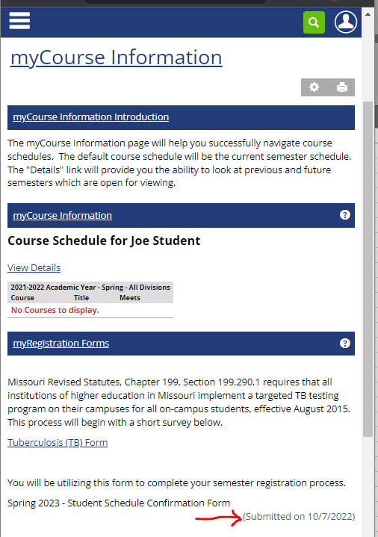

Scroll to the bottom to “myRegistration Forms” and complete the Student Schedule Confirmation Form.
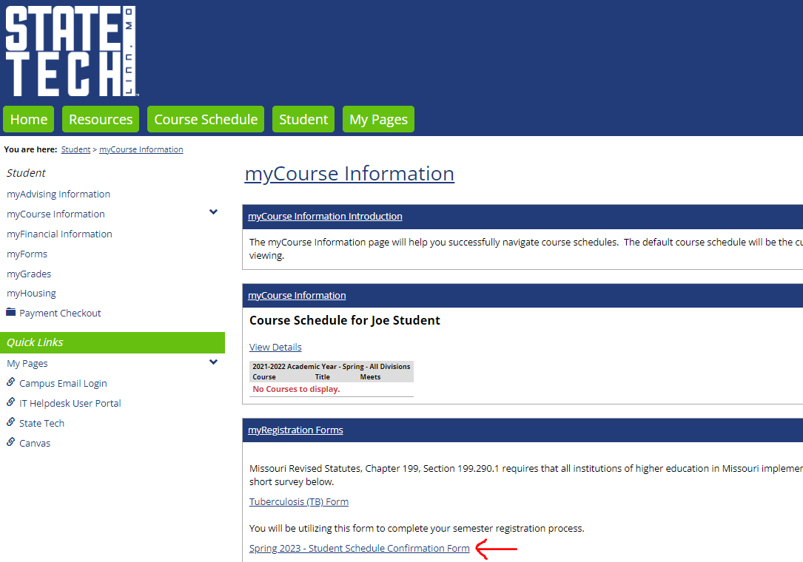

Once completed, verify both forms show “Submitted”
