MOBILE DEVICE
Log into mytech.statetechmo.edu/ics
Username = firstname.lastname@iam.statetechmo.edu
Password = Email Password
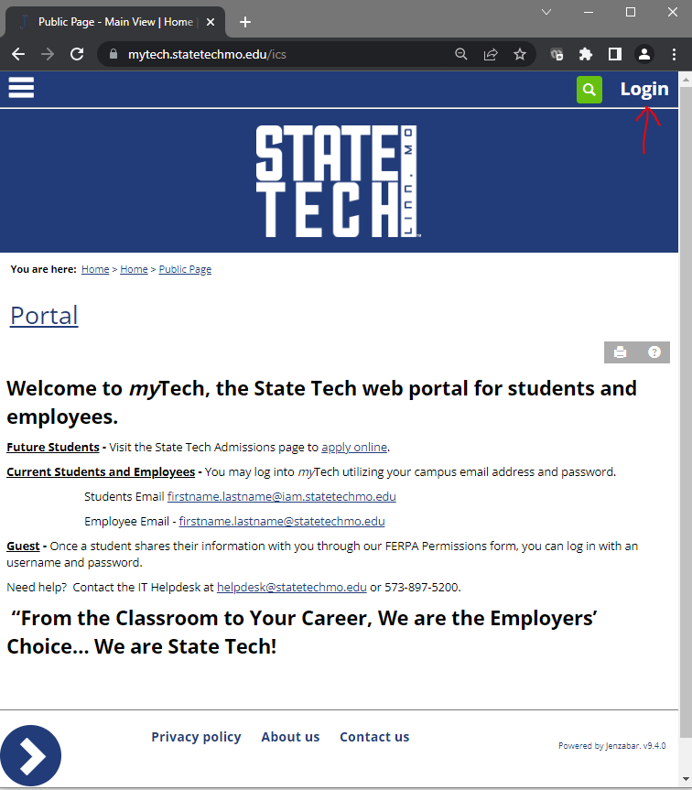

Select the hamburger icon in the upper left corner and then select “Student”
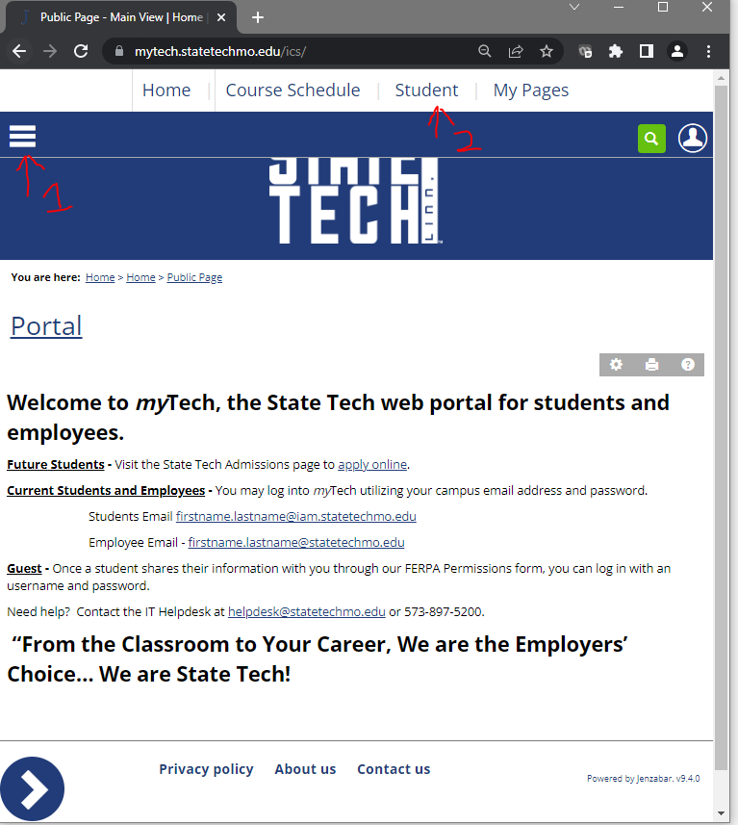

DESKTOP
Log into mytech.statetechmo.edu/ics
Username = firstname.lastname@iam.statetechmo.edu
Password = Email Password
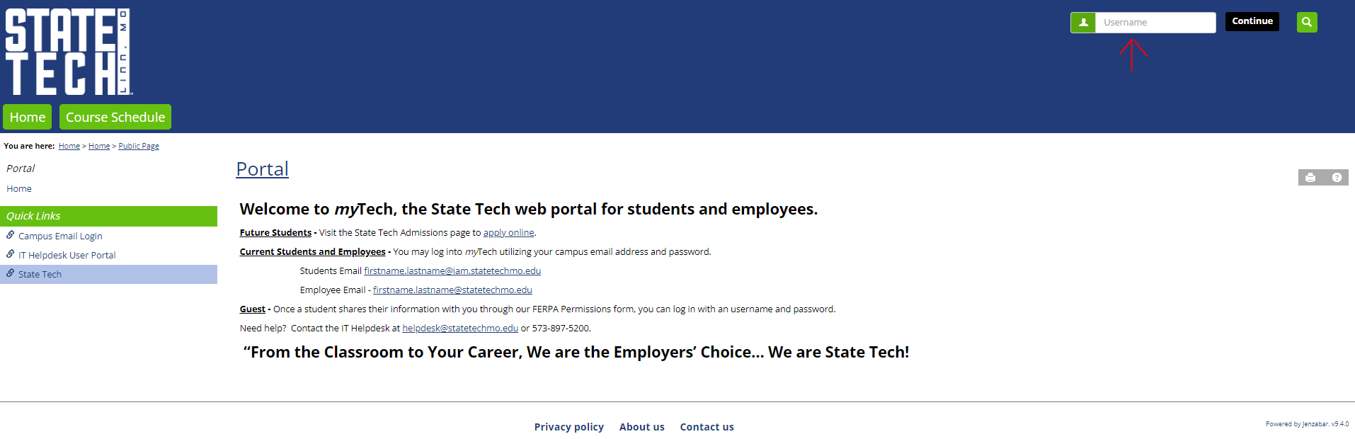

Select the “Student” tab
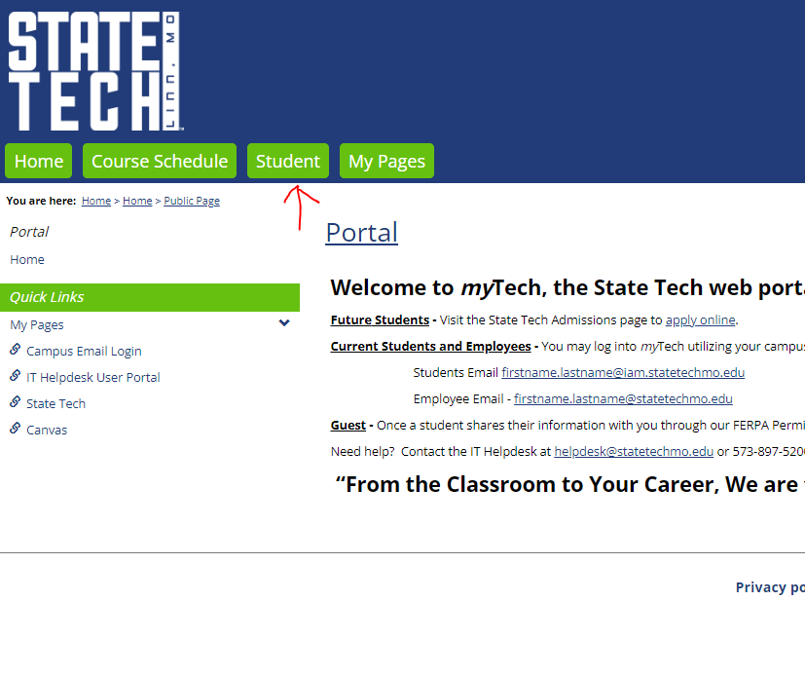

Select the arrow icon in the bottom left corner of the screen.
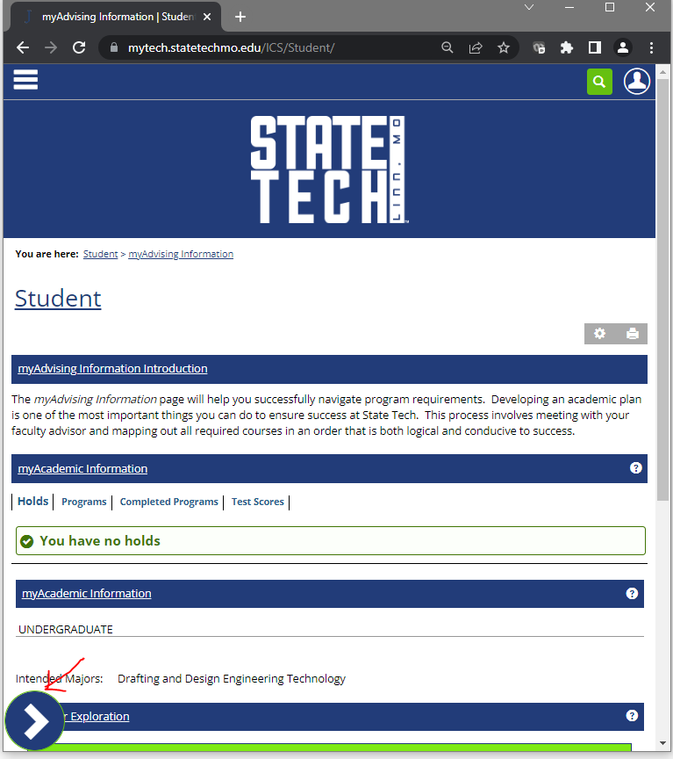

Select “myGrades Information”
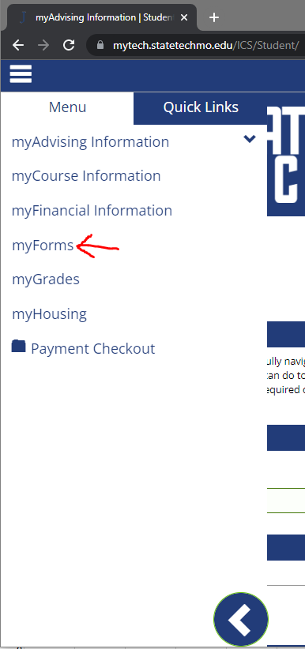

Select “myGrades Information”
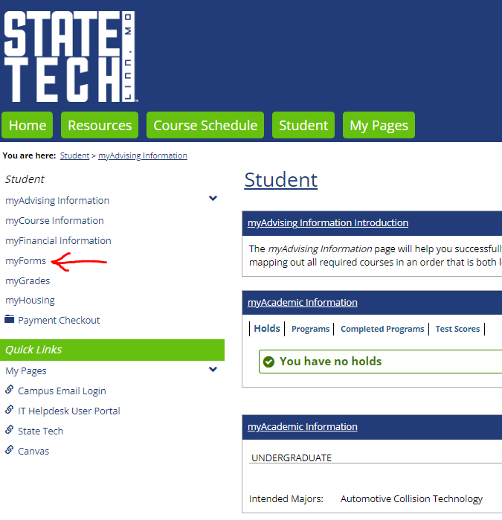

myUnofficial Transcript – The unofficial transcript lists, in addition to your academic work at State Tech, your transfer academic work, permanent address, term and cumulative GPA and Job Readiness and Attendance information.
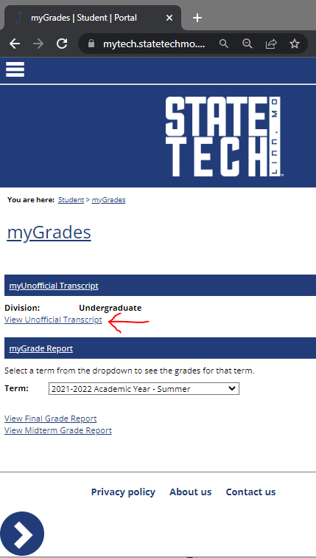

myUnofficial Transcript – The unofficial transcript lists, in addition to your academic work at State Tech, your transfer academic work, permanent address, term and cumulative GPA and Job Readiness and Attendance information.
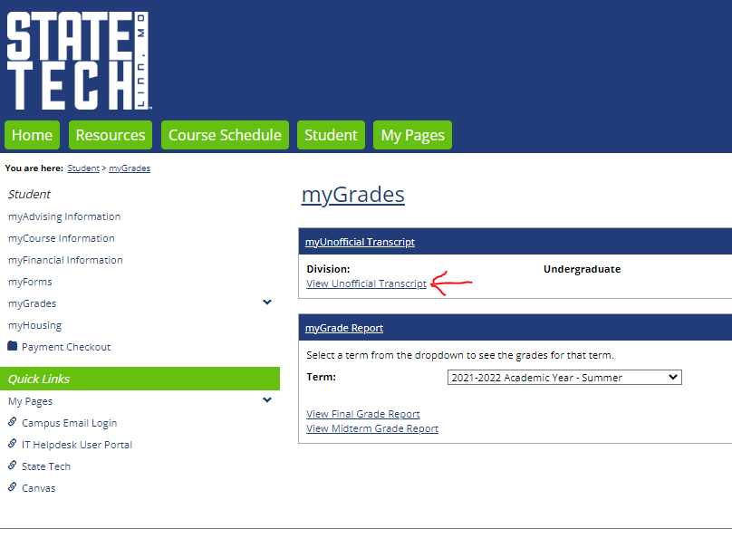

Here is a screenshot of a sample unofficial transcript. The “myUnofficial Transcript” PDF icon at the bottom of the screen will allow you to print a copy of your unofficial transcript.
