MOBILE DEVICE
Log into mytech.statetechmo.edu/ics
Username = firstname.lastname@iam.statetechmo.edu
Password = Email Password
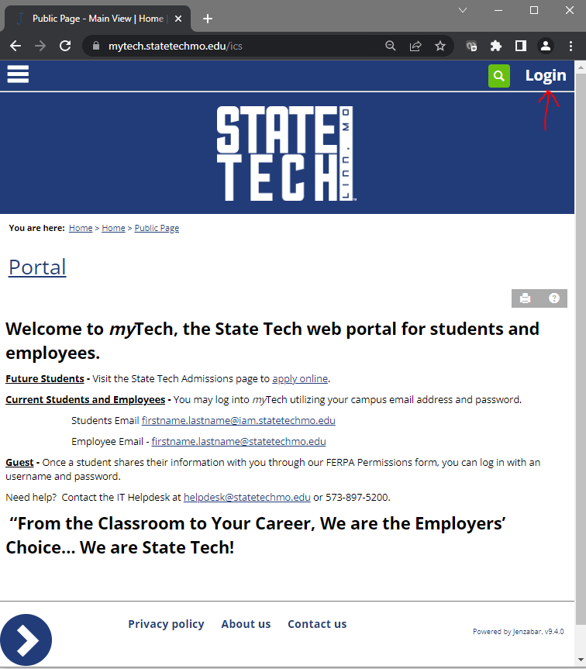

Select the hamburger icon in the upper left corner and then select “Student”
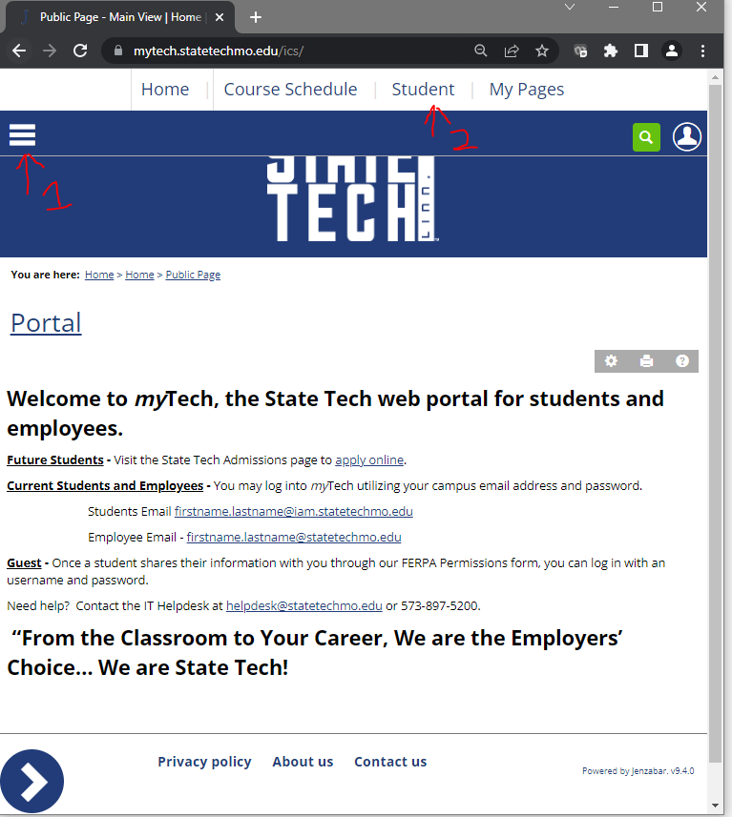

DESKTOP
Log into mytech.statetechmo.edu/ics
Username = firstname.lastname@iam.statetechmo.edu
Password = Email Password
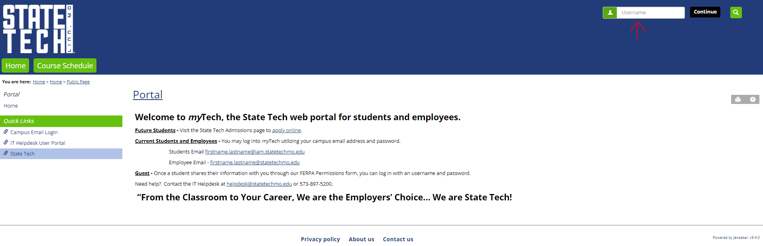

Select the “Student” tab
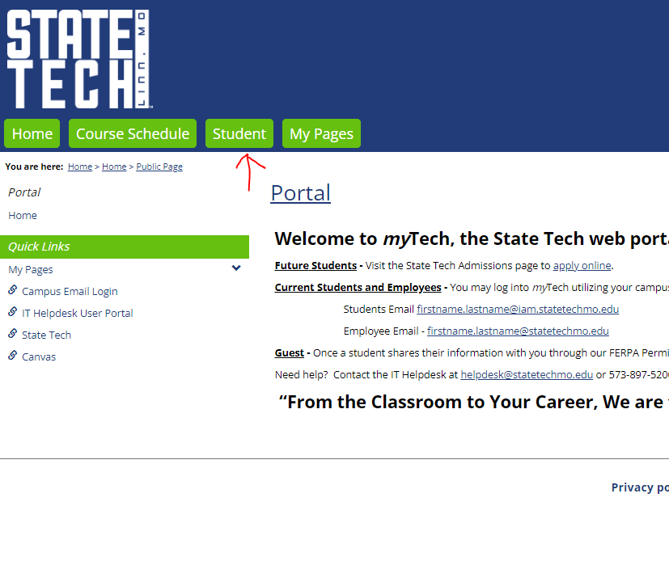

Select the arrow icon in the bottom left corner of the screen.
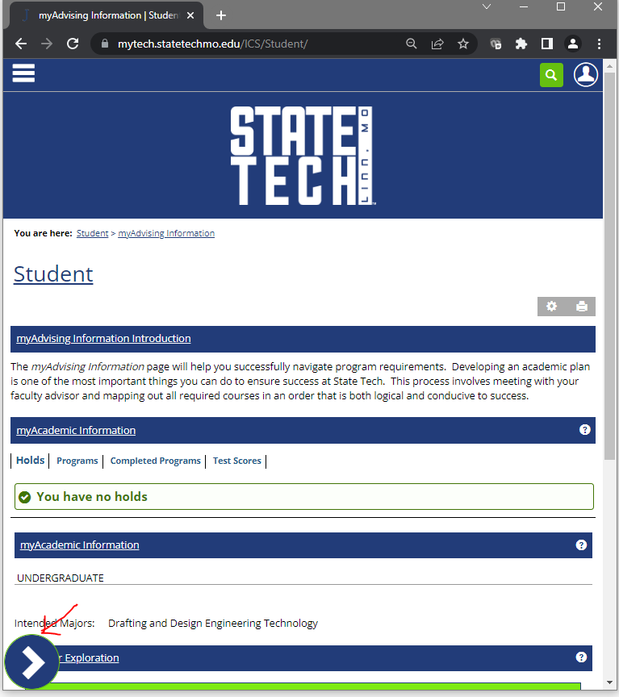

Select “myFinancial Information”
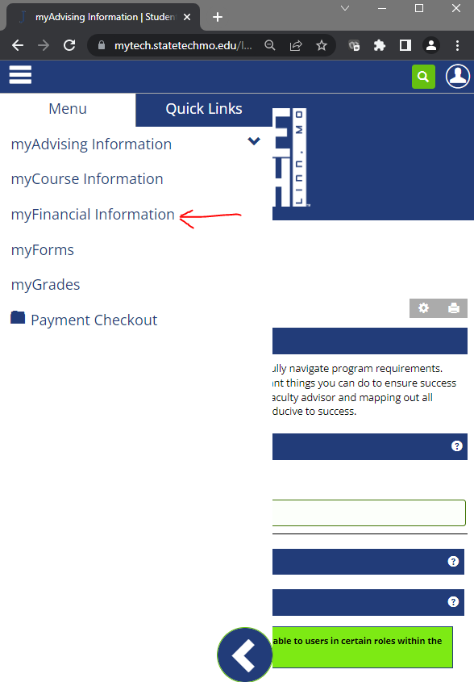

Select “myFinancial Information”
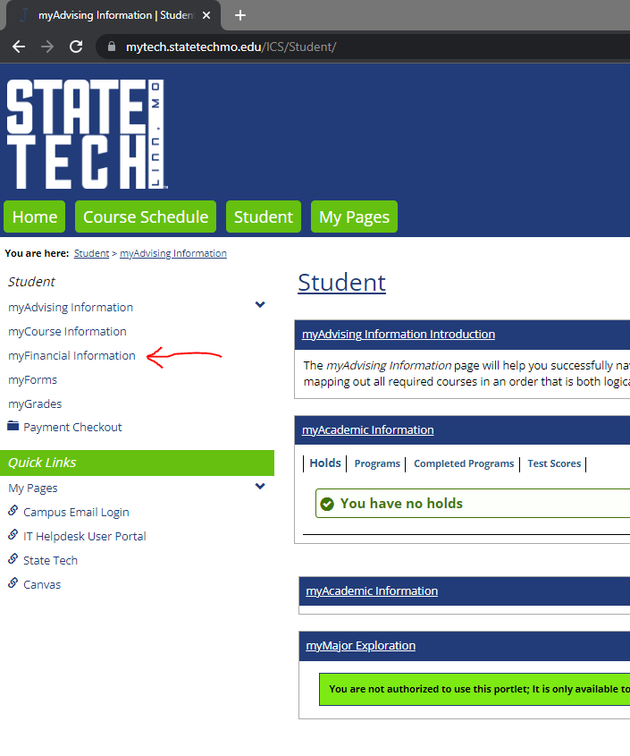

To View Your Account Statement:
Scroll to “myFinancial Account” and select “Account Statement”.
A PDF generated statement will show up as a link to select and your “Account Statement” will show in a PDF file to you.
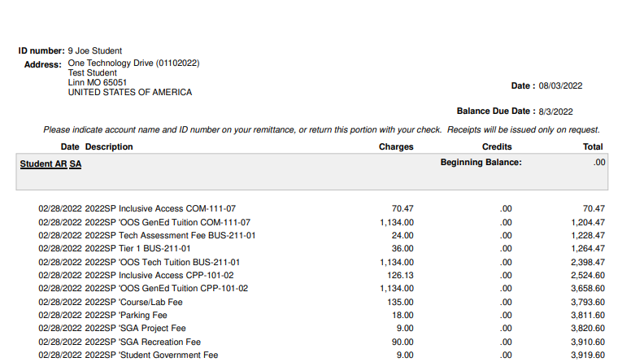
To View Your Balance Due:
Scroll to “myFinancial Account” and select the term in which you would like to view your balance.
To Make a Payment:
Scroll to “myFinancial Account” and select the term in which you would like to see your balance and select “Make payment”.
Select the term and year you would like to have the payment associated with and select “Continue payment checkout”.
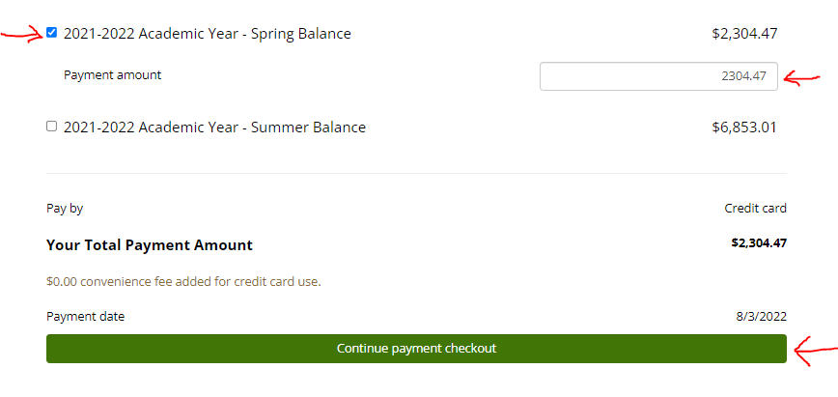
Enter in your payment information and select “Pay”
